# **Game Proposal: The Fast and The Furry-ous**

# **CPSC 427 - Video Game Programming, Winter 21/22**

**Story:**

* Background Context
  + Two groups of pets are neighbors and don’t like each other, so they fight
* Major Levels
  + There will be a tutorial level but besides that
  + There are no levels; this is a turn-based game where players battle each other until one team is eliminated
  + There will be a few different maps
* Game Rules
  + Each game should only last around 5 - 10 mins
  + Team that runs out of pets first is eliminated
  + A pet is eliminated if their hp runs out
  + Each team has the same number of pets (3-5, depending on player-chosen settings)
  + Each turn one action (move, attack, defend) can be made on each team
    - Attack: Do one attack
    - Move: Move a certain distance
  + Each time has 30 seconds to choose their action
* Player Goals
  + Eliminate all of the pets on the opposing team

**Technical Elements:**

* Rendering
  + 2D side-view perspective
  + Two opposite environmental structures that serve as bases (houses)
  + Character action and projectile animation
  + Number of characters on each side
  + HP bar or number of lives
* Assets (Geometry, Sprites, Audio)
  + Pixel sprites for pets/units/weapons
  + Sounds for player actions (feedback)
  + Background music
  + Squares and triangles for shaping the environment/map terrain
* 2D Geometry Manipulation
  + Sprites can move, jump, and attack
* AI/Gameplay Logic
  + User can play against AI or another user
* Physics
  + Physics to calculate trajectory of ranged attacks (power, distance, direction)
  + Collision detection (projectile hitting a pet, pets not going through the terrain elements)
  + Universal gravity that affects everything (both projectiles and character movement)

**Advanced Technical Elements:**

* Multiple pets to choose from for each team
  + There will be less customizability if this is skipped, but no major impact on gameplay
  + Instead of different pets, we could allow each player to choose a different colour to customize their team’s base
  + If time permitting the different pets can have different weapons, with different properties i.e launch angle, destructive force etc
* Allowing pets to defend incoming attacks
  + If skipped, gameplay will be quicker
  + An alternative to this is allowing players to ‘revive’ pets
* Terrain or environmental changes due to collisions (base/terrain destruction)
  + There will be less variability in gameplay if this is skipped

**Devices:**

* Mouse and Keyboard
  + Up/down/left/right will be used for character sprite movement
  + The mouse will be used to aim and fire projectiles

**Concepts:**

* Starting screen will include a list of choices for the player, and a game title with a game graphic in the background.
  + A list of choices includes a “play” button, “options” button, and a “quit” button

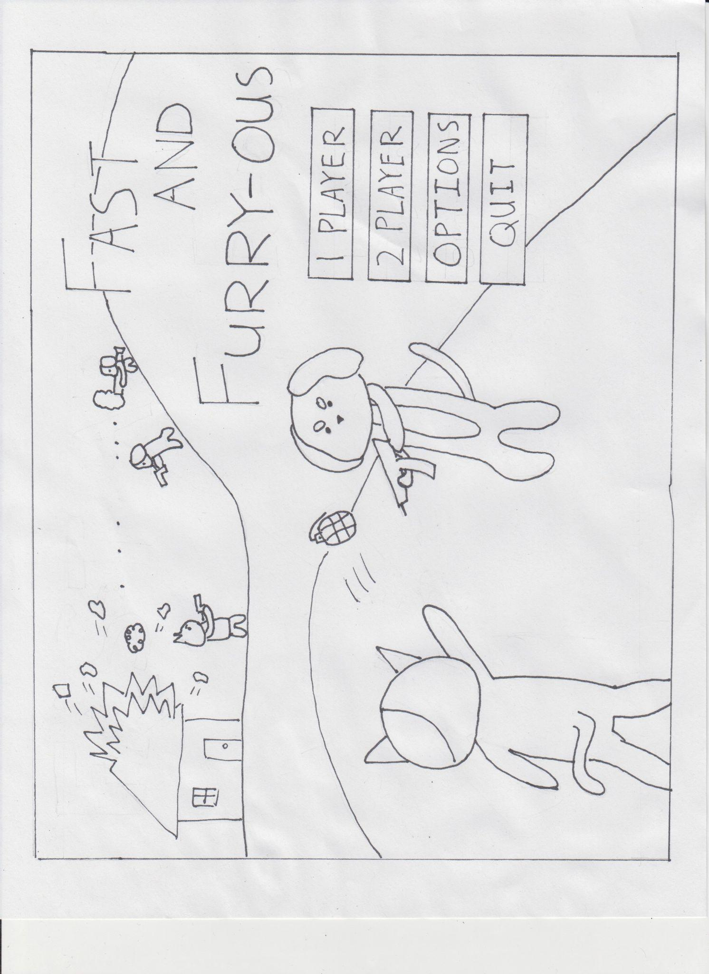.

* In case of selecting the play button, the game will be directed to the team select screen for the players to choose their side.

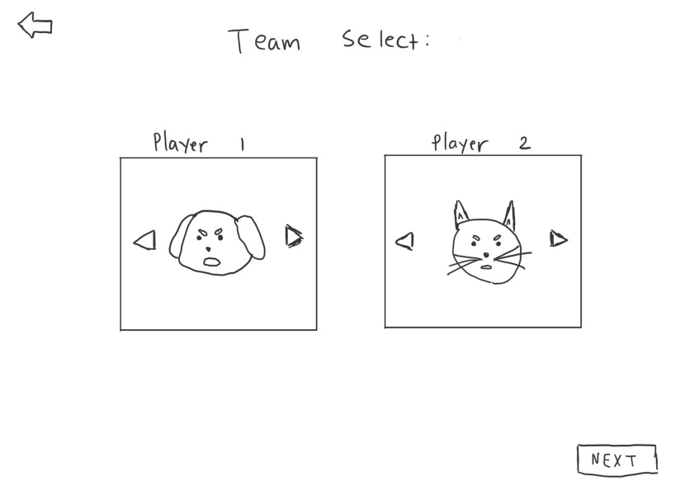

* Once the teams are assigned to each player, the in-game screen will be rendered with 3 characters on each side.

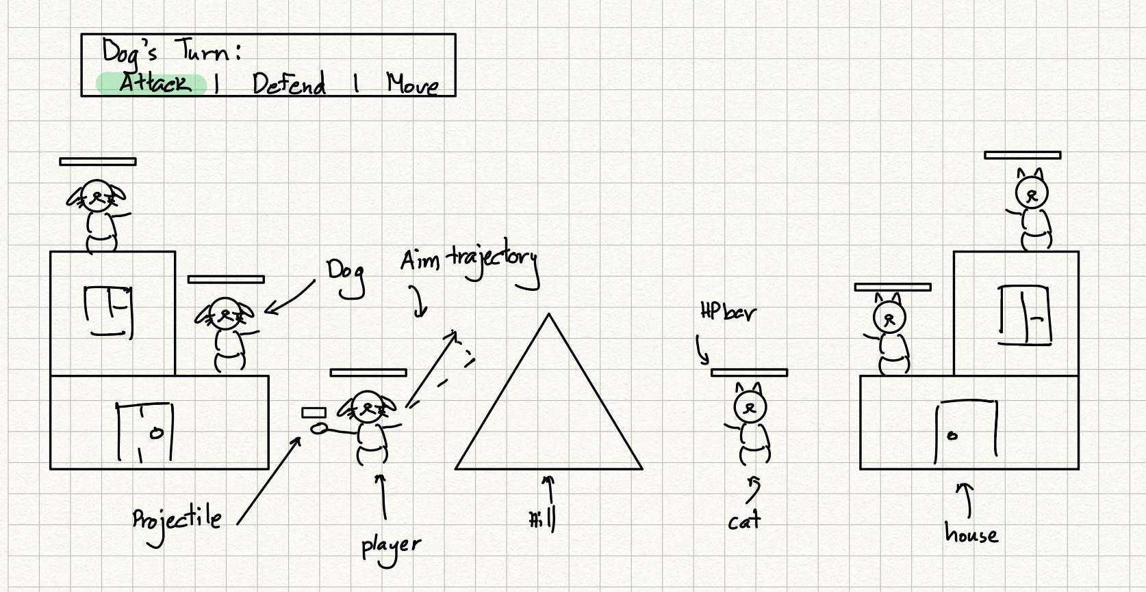

**Tools:**

* No additional tools will be used

**Team Management:**

* Using workflow manager ClickUp to track tasks
  + Deadlines and task assignments will be tracked here, and it is expected that each team member will complete their assigned tasks on-time
  + Major deadlines are outlined below, internal deadlines will be decided on a sprint-to-sprint basis
* Using Discord for team communication

**Development Plan:**

**Skeletal Game**

Week 1

* Gameplay
  + Setting up an ECS architecture
  + Creating the player
  + Creating the blocks/terrain
* Rendering
  + Basic platforms for characters to stand on
  + Add character blocks

Week 2

* Gameplay
  + Moving characters
  + Object Collision - basic detection and avoidance
* Rendering
  + Add basic textures/sprites
* Testing & bug fixing

**Minimal Playability**

Week 1

* Gameplay
  + Create and implement a simple decision tree structure for user input
    - Player turn system
    - Character attacks
    - Character moves
    - Start Menu
    - Team/Character select
    - Victory conditions
* Animation
  + Create 2 sprite sheets (one for each type of pet)
* Assets
  + New sprites for pet types
  + Map & terrain textures

Week 2

* Gameplay
  + Add health and death state to characters
* Animation
  + Pets react to taking damage (visual feedback)
* Assets
  + Background music

Week 3

* Gameplay
  + Implement aiming projectiles
  + Implement moving logic - players only allowed to move certain distances
  + Start working on CPU opponent
* Help
  + Implement basic hints/user tutorial
* Testing & bug fixing

**Advanced Game**

Week 1

* Gameplay
  + Bug fixing
  + Work on stability and robustness as outlined in the doc
* Animations
  + Add fancier physics-based projectile animations
* Assets
  + Assets for all UI graphical info needs to be created
    - Turn #, player options, player turn
    - Start Screen, character select screen

Week 2

* Gameplay
  + Bug fixing
  + Work on stability and robustness as outlined in the doc
  + Make the terrain more complex using various geometric assets
* Animations
  + Add fancy idle animations
* Assets
  + Assets for weapons

Week 3

* Documentation
* Gameplay
  + Implement correct collision detection for the complex geometry
* Assets
  + Add different textures for different weapons

**Final Game**

Week 1

* Stability
  + Fix all previously identified bugs
* User Experience
  + Create tutorial explaining game mechanics
* Creative Components
  + Include advanced graphics (particle system, 2D dynamic shadows)
  + Implement advanced physics system (gravity)

Week 2

* Creative Components
  + Add audio feedback for all meaningful game interactions

Week 3

* Documentation
* Finish any other tasks or fix issues found in previous weeks